Cloud Computing Class Project 3 Final Report

CSCI 4450/6400 Cloud Computing Spring 2020

# Introduce the AWS services that you used.

We used LightSail to Host the website.

We used DynamoDB for the database.

We used AWS S3 to store the resumes.

We used AWS IAM role to grant permissions to entities.

# Describe how you connect those services (system architecture or dataflow)

The website runs on LightSail Ubuntu instance using apache2. The website then uses python scripts to execute database transfer using the library CGI to allow Http requests to be sent to the script. The script then used BOTO3 to create a connection between the amazon s3 bucket and the DynamoDB database and then transfers the data to the corresponding services.

# List any technology that is not mentioned in the project description for getting bonus.

We used Cloud 9 to write code and WinSCP for file handling on the server.

We also use CGI script to handle user submitted data and Boto3 to connect to AWS services

# Please attach your codes (application) or a GitHub link to your project along with this report.

This is the Github link to our project. the dbupload file is the python script for uploading the user data to the AWS services. The Elements file is the HTML file that contains the code to Make the POST to the python script.

<https://github.com/yibozhu45/AWS-project/tree/master/AUM%20Computer%20Science%20Website>

# Input/Output (take screenshots from your apps)

* 1. AWS Service 1: Dynamo DB

Screenshot of input and output:

input page

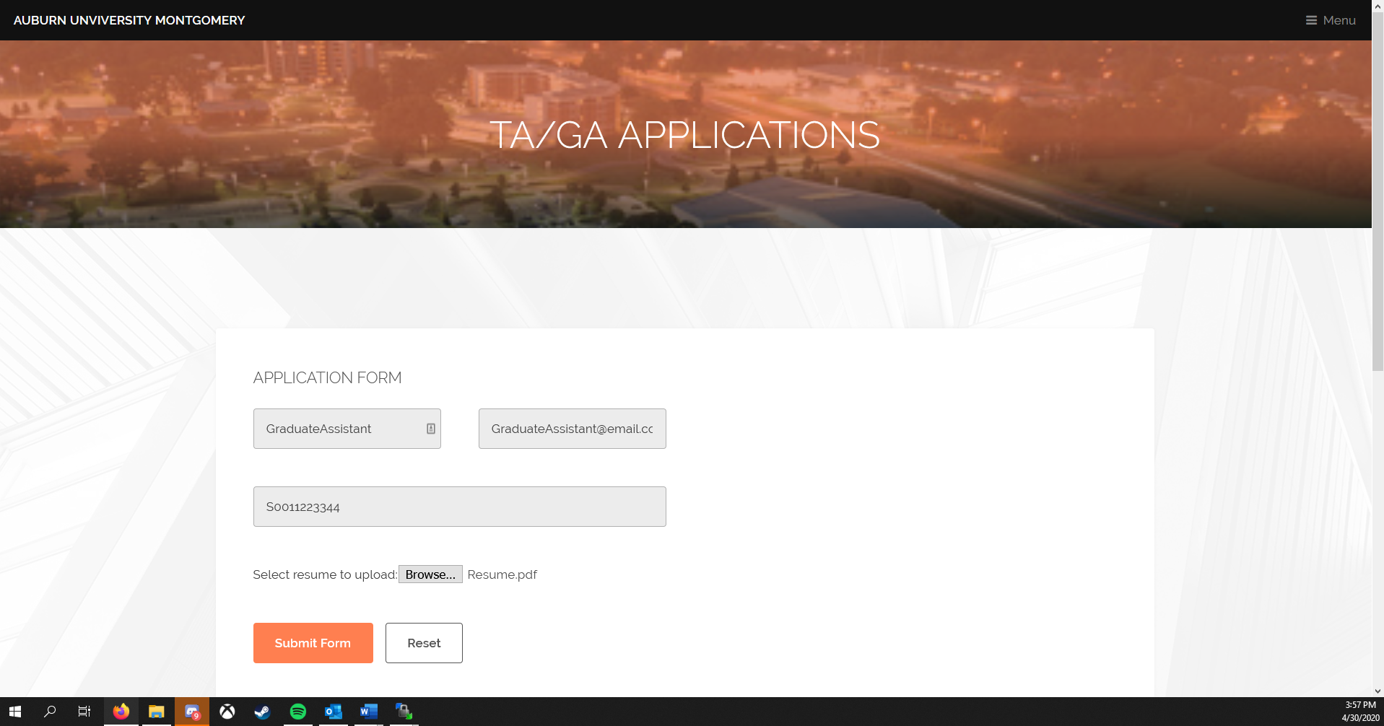

network showing that the file was sent to the dpUpload script

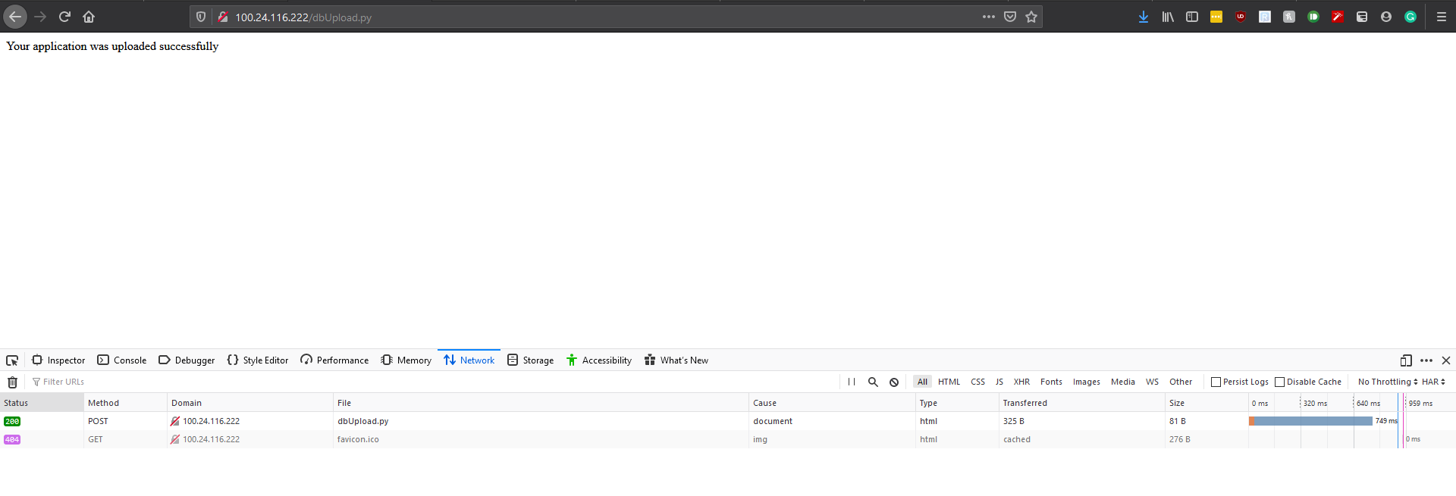

The user info that has been transferred to the database

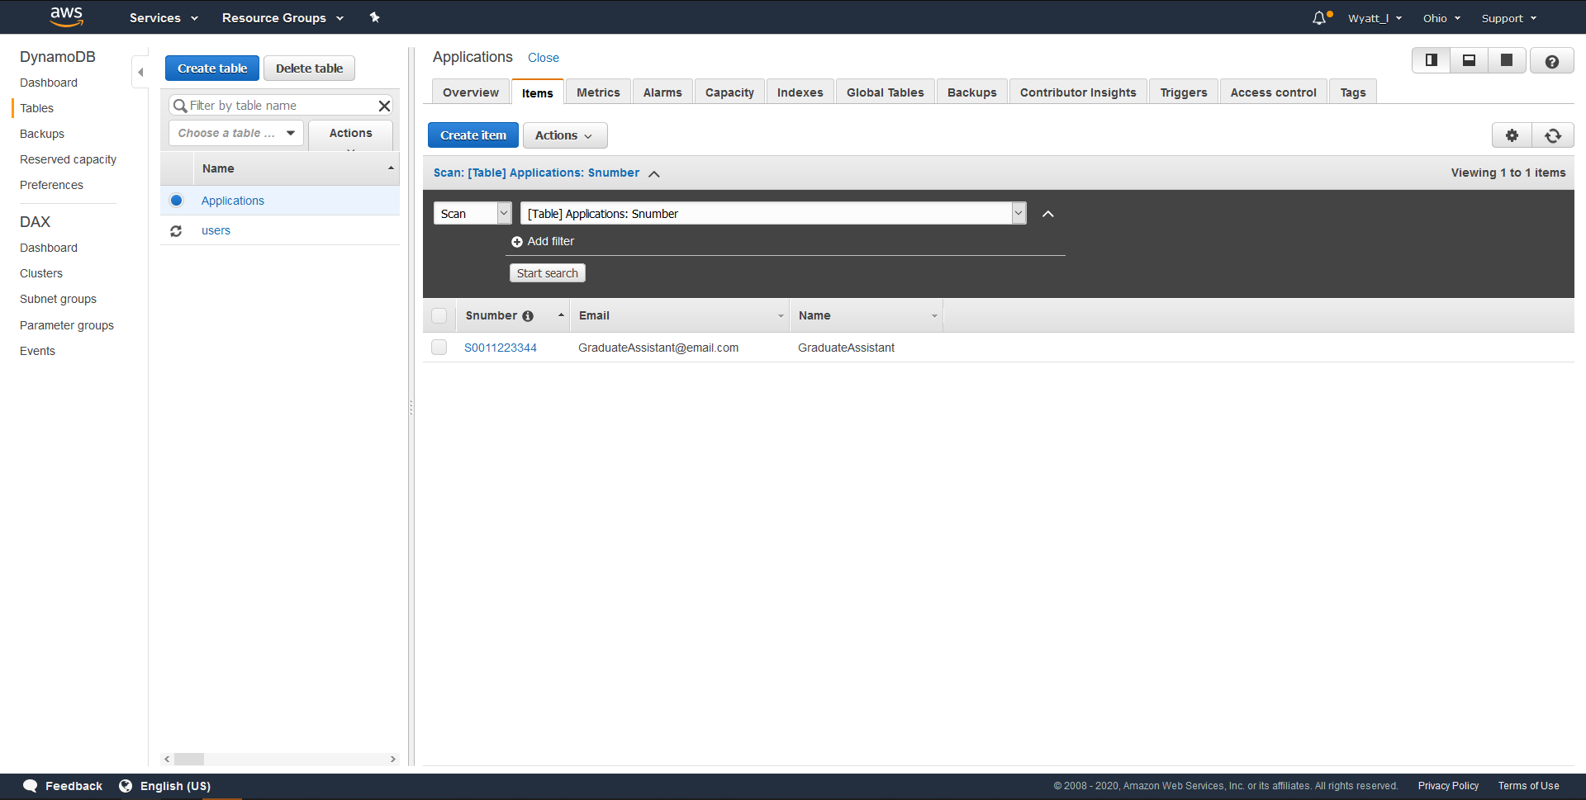

* 1. AWS Service 2: AWS S3

Screenshot of input and output:

Input: the browse function that allows you to select your resume before uploading

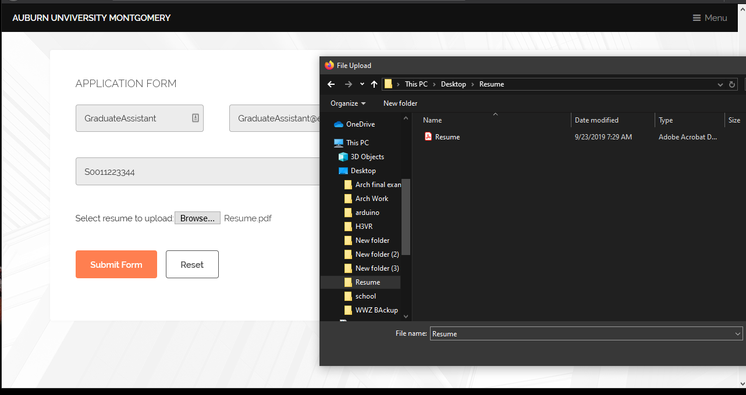

network showing that the file was sent to the dpUpload script



The s3 showing that the resume was renamed and uploaded

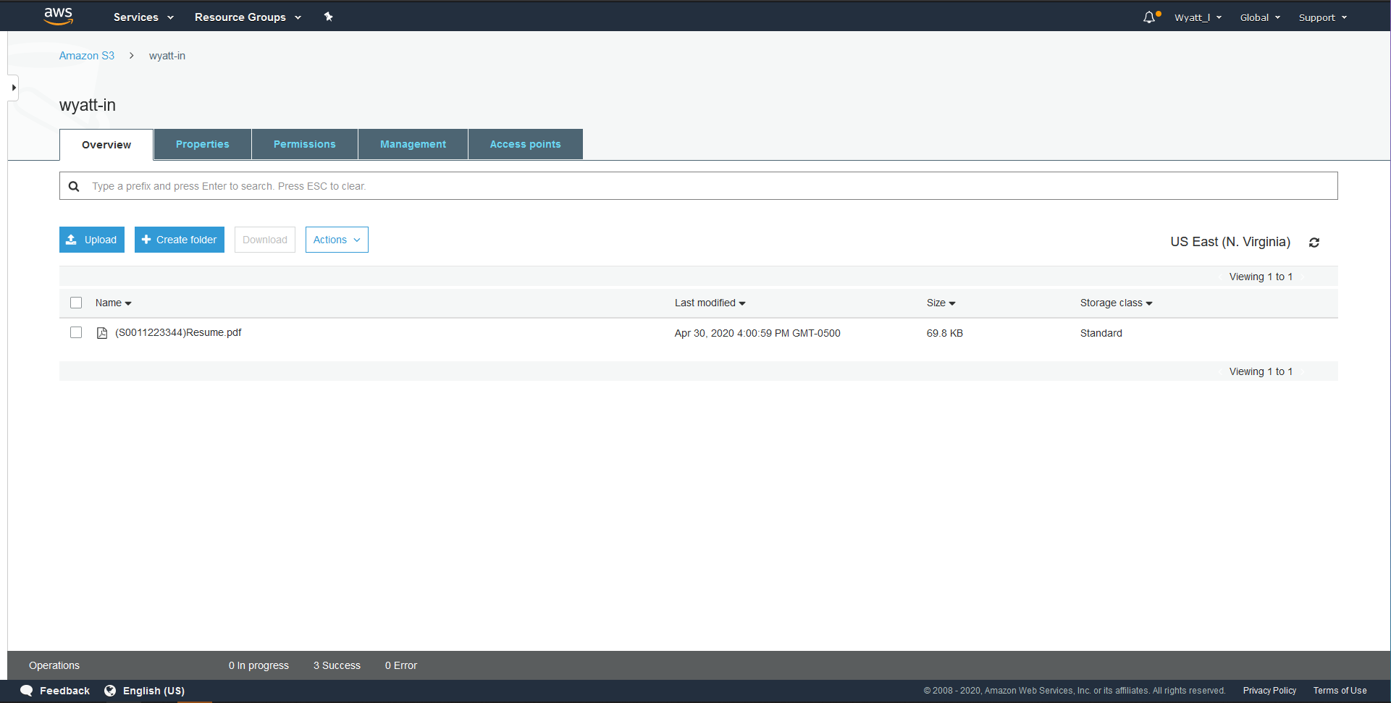

The Resume is uploaded to S3 and labeled first with the student number in parenthesis and then followed by the name of the uploaded file. This is done to make it easy to find the user who submitted the resume since the database is sorted using the primary key Student number.

AWS Service3: Lightsail to host the website

AWS Service4: IAM to access s3 and DynamoDB

# Screenshot of output from other things that you want to post here.

